



Biological Sciences: Classification

**Year 7 Science**

Biological Sciences: Classification

© Department of Education WA 2020

Except where indicated, this content is © Department of Education Western Australia 2020 and released under a Creative Commons CC BY NC licence. Before re-purposing any third-party content in this resource refer to the owner of that content for permission.

Requests and enquiries concerning copyright should be addressed to:

Manager Intellectual Property and Copyright

Department of Education

151 Royal Street

EAST PERTH WA 6004

Email: [copyright@education.wa.edu.au](mailto:copyright@education.wa.edu.au)



<https://creativecommons.org/licenses/by-nc/4.0/>

**Year 7: Biological Sciences: Classification**

**Instructions to Students:**

This resource package provides students with learning materials for the Biology Year 7 course.

This package is designed to support the program students are completing at their school.

If feedback is required when completing this package, students should consult their teacher.

It is recommended that students further investigate concepts covered in this resource package by conducting

their own research using the text/s that they use at school or the internet.

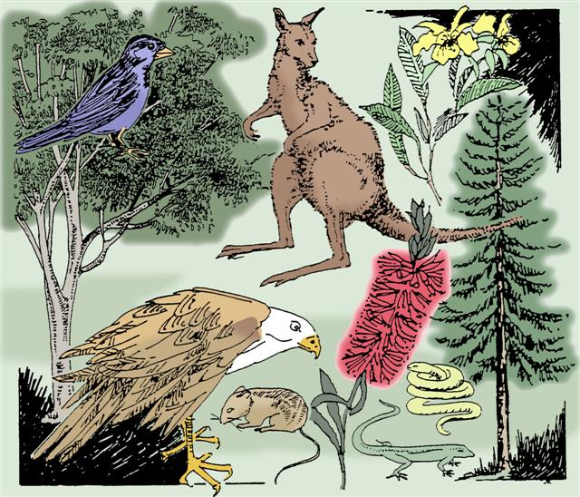

**Science Understanding**

**Biological Sciences**

**Classification helps organise the diverse group of organisms** [(ACSSU111)](https://k10outline.scsa.wa.edu.au/home/teaching/codes/science/year-7/acssu111)

**Elaborations**

* considering the reasons for classifying such as identification and communication
* grouping a variety of organisms on the basis of similarities and differences in particular features
* considering how biological classifications have changed over time

**Biology Glossary**

As you work through the content there will be certain words that you need to learn that will help in your understanding of the topic being studied.

For each of the words listed below

1. See if you can predict/guess what they may mean.
2. Use a dictionary, your textbook or your workbook to write the correct scientific definition.
3. Write down any variations or different ways there may be of saying/using/writing the word. (Sometimes there may be no variation)
4. Draw a diagram if it helps you remember the word/phrase, or use the word correctly in a sentence.

|  |  |  |  |  |
| --- | --- | --- | --- | --- |
| **Word/phrase** | **Prediction** | **Definition** | **Variation of**  **word** | **Diagram or example** |
| **Classification** |  |  |  |  |
| **Taxonomy** |  |  |  |  |
| **Taxonomists** |  |  |  |  |
| **Binomial nomenclature** |  |  |  |  |
| **Dichotomous keys** |  |  |  |  |

**Study Notes**

**Classification**

Classification is the arrangement of organisms into orderly groups based on their similarities.

Classification is also known as **TAXONOMY.**

**TAXONOMISTS** are scientist that identify and name organisms.

**Why do we need to classify**?

It is easier to study things if they are put into groups according to similar characteristics.

Examples:

* Students placed in year groups in a school.
* Items on the supermarket shelf.

Can you think of other examples of where items are grouped together?

|  |
| --- |
|  |

|  |
| --- |
|  |

**Let’s look closely at the following shapes**:

How can we Classify them according to similar characteristics or properties?

|  |  |
| --- | --- |
|  |  |

**Question set 1: Grouping things together**

All your life you have been grouping things, Words like tree, dog, car and house are examples of things we have classified. Take houses for example. Not all houses are the same. They usually look different from one another. They have several things in common like a roof, a door and people who live inside them.

Look at the pictures below. They show a variety of vehicles. All images on this page are from

**clipart-library.com**

You can check your understanding with possible answers/solutions provided at the end of this book.

|  |  |
| --- | --- |
|  | C:\Users\E0415728\Desktop\Screen captures\2020-04-21_114848.jpg |
| C:\Users\E0415728\Desktop\Screen captures\2020-04-21_114950.jpg | C:\Users\E0415728\Desktop\Screen captures\2020-04-21_115019.jpg |
|  | C:\Users\E0415728\Desktop\Screen captures\2020-04-21_114946.jpg |
| C:\Users\E0415728\Desktop\Screen captures\2020-04-21_114919.jpg | C:\Users\E0415728\Desktop\Screen captures\2020-04-21_114753.jpg |
| C:\Users\E0415728\Desktop\Screen captures\2020-04-21_114825.jpg | C:\Users\E0415728\Desktop\Screen captures\2020-04-21_115055.jpg |
| C:\Users\E0415728\Desktop\Screen captures\2020-04-21_114937.jpg | C:\Users\E0415728\Desktop\Screen captures\2020-04-21_115033.jpg |

List some things they all have in common. Wheels would be one example.

\_\_\_\_\_\_\_\_\_\_\_\_\_\_\_\_\_\_\_\_\_\_\_\_\_\_\_\_\_\_\_\_\_\_\_\_\_\_\_\_\_\_\_\_\_\_\_\_\_\_\_\_\_\_\_\_\_\_\_\_\_\_\_\_\_\_\_\_\_\_

\_\_\_\_\_\_\_\_\_\_\_\_\_\_\_\_\_\_\_\_\_\_\_\_\_\_\_\_\_\_\_\_\_\_\_\_\_\_\_\_\_\_\_\_\_\_\_\_\_\_\_\_\_\_\_\_\_\_\_\_\_\_\_\_\_\_\_\_\_\_

\_\_\_\_\_\_\_\_\_\_\_\_\_\_\_\_\_\_\_\_\_\_\_\_\_\_\_\_\_\_\_\_\_\_\_\_\_\_\_\_\_\_\_\_\_\_\_\_\_\_\_\_\_\_\_\_\_\_\_\_\_\_\_\_\_\_\_\_\_\_

Now list some differences between the vehicles.

\_\_\_\_\_\_\_\_\_\_\_\_\_\_\_\_\_\_\_\_\_\_\_\_\_\_\_\_\_\_\_\_\_\_\_\_\_\_\_\_\_\_\_\_\_\_\_\_\_\_\_\_\_\_\_\_\_\_\_\_\_\_\_\_\_\_\_\_\_\_

\_\_\_\_\_\_\_\_\_\_\_\_\_\_\_\_\_\_\_\_\_\_\_\_\_\_\_\_\_\_\_\_\_\_\_\_\_\_\_\_\_\_\_\_\_\_\_\_\_\_\_\_\_\_\_\_\_\_\_\_\_\_\_\_\_\_\_\_\_\_

\_\_\_\_\_\_\_\_\_\_\_\_\_\_\_\_\_\_\_\_\_\_\_\_\_\_\_\_\_\_\_\_\_\_\_\_\_\_\_\_\_\_\_\_\_\_\_\_\_\_\_\_\_\_\_\_\_\_\_\_\_\_\_\_\_\_\_\_\_\_

\_\_\_\_\_\_\_\_\_\_\_\_\_\_\_\_\_\_\_\_\_\_\_\_\_\_\_\_\_\_\_\_\_\_\_\_\_\_\_\_\_\_\_\_\_\_\_\_\_\_\_\_\_\_\_\_\_\_\_\_\_\_\_\_\_\_\_\_\_\_

You could group the vehicles into those with headlights and those without headlights or according to colour.

When you sort things into groups we call it **classifying**.

Every day you sort things into groups. You may not even know you are doing it. Take the morning newspaper for example. Usually you have the general news in the first section and the television guide is in the middle. Items for sale and the sports news are found at the back of the paper. Have a look at your local paper to see how it is organised.

**Let’s look at your fridge**.

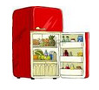

**Image by clipart-library.com**

In your fridge food has been organised and packed in different groups.

What are some of the groups and why is this useful?

\_\_\_\_\_\_\_\_\_\_\_\_\_\_\_\_\_\_\_\_\_\_\_\_\_\_\_\_\_\_\_\_\_\_\_\_\_\_\_\_\_\_\_\_\_\_\_\_\_\_\_\_\_\_\_\_\_\_\_\_\_\_\_\_\_\_\_\_\_\_\_\_\_\_

\_\_\_\_\_\_\_\_\_\_\_\_\_\_\_\_\_\_\_\_\_\_\_\_\_\_\_\_\_\_\_\_\_\_\_\_\_\_\_\_\_\_\_\_\_\_\_\_\_\_\_\_\_\_\_\_\_\_\_\_\_\_\_\_\_\_\_\_\_\_\_\_\_\_

In your fridge, items are stored in a certain way. Name four things you might classify as vegetables.

\_\_\_\_\_\_\_\_\_\_\_\_\_\_\_\_\_\_\_\_\_\_\_\_\_\_\_\_\_ \_\_\_\_\_\_\_\_\_\_\_\_\_\_\_\_\_\_\_\_\_\_\_\_\_\_\_\_\_

\_\_\_\_\_\_\_\_\_\_\_\_\_\_\_\_\_\_\_\_\_\_\_\_\_\_\_\_\_ \_\_\_\_\_\_\_\_\_\_\_\_\_\_\_\_\_\_\_\_\_\_\_\_\_\_\_\_\_

Name four things you might classify as dairy products.

\_\_\_\_\_\_\_\_\_\_\_\_\_\_\_\_\_\_\_\_\_\_\_\_\_\_\_\_\_ \_\_\_\_\_\_\_\_\_\_\_\_\_\_\_\_\_\_\_\_\_\_\_\_\_\_\_\_\_

\_\_\_\_\_\_\_\_\_\_\_\_\_\_\_\_\_\_\_\_\_\_\_\_\_\_\_\_\_ \_\_\_\_\_\_\_\_\_\_\_\_\_\_\_\_\_\_\_\_\_\_\_\_\_\_\_\_\_

**Now let’s organise your pencil case**

* Tip out the contents of your pencil case.
* Look at the items in the pencil case.
* Sort the items into groups.

**Open a word document to write your answer or write it on file paper.**

1. How did you decide what was included in each group?

2. Now try re-sorting your pencil case. Do you have the same number of groups? Explain your answer

**VIDEO**

If you have the opportunity you can view this video to support your understanding of classification.

<https://www.youtube.com/watch?v=M51AKJqx-7s&list=PLEmXJaDnCA6nJIXACwKktyDze1tYYZPha&index=3>

**Study Notes: Clasification**

Sorting things that are alike in some way into groups is called **classifying**.

Classifying is useful to us because it helps us to:

* identify things such as plants and animals and name them correctly. A tree can be identified as a jarrah tree and a bird as a magpie.
* find patterns and work out similarities between things.

 

When scientists classify things into groups, each of the things in the group tends to have a lot of features in common. As the groups get smaller the things become more alike. Eventually each thing will be placed its own group because there is no other thing that is exactly like it. The scientists pick out features that make that thing different to all of the others when they classify it.

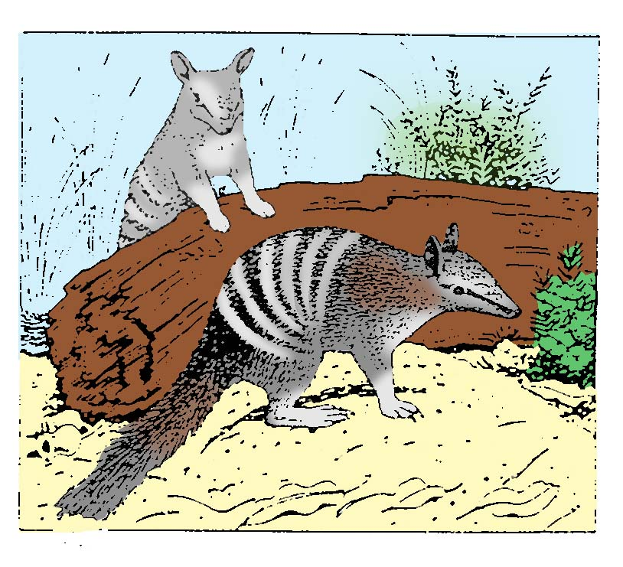

Images: SIDE resources

**Study Notes: Reading and creating Biological Keys**

If you have the opportunity you can view this video to support your understanding of Biological keys.

<https://www.youtube.com/watch?v=ghlUUodEFog>

Biologists cannot be expected to know and be able to name all living organisms. How then, can biologists work out the scientific name of an unfamiliar organism? The simple answer is that they use a key. They use a key in a similar way to a road map, to find their way to the specific name.

The most common type of biological key is the **dichotomous key.** The word dichotomous means division into two and in this type of key, the user needs only to make a series of choices between two alternatives to reach a conclusion. At each step, all the objects are divided into two groups.

To create a dichotomous key, you will start with a **tree diagram**. See example below

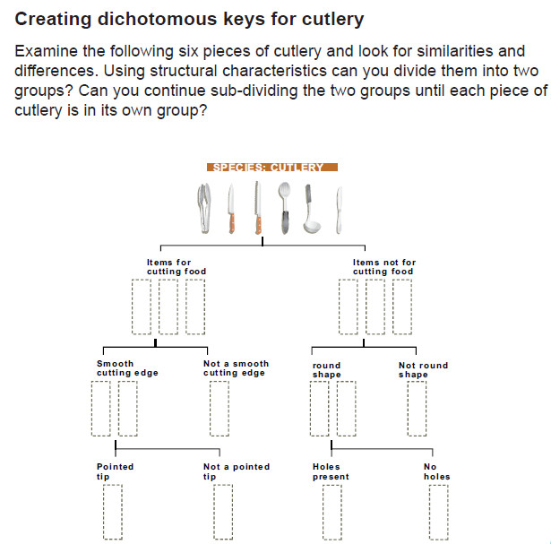

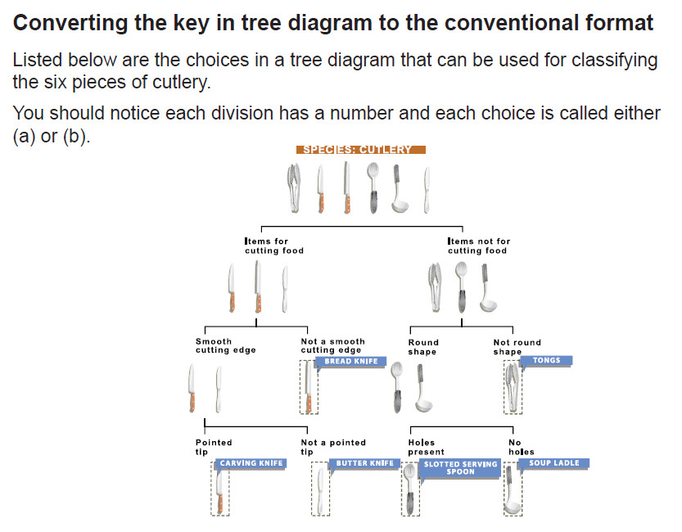

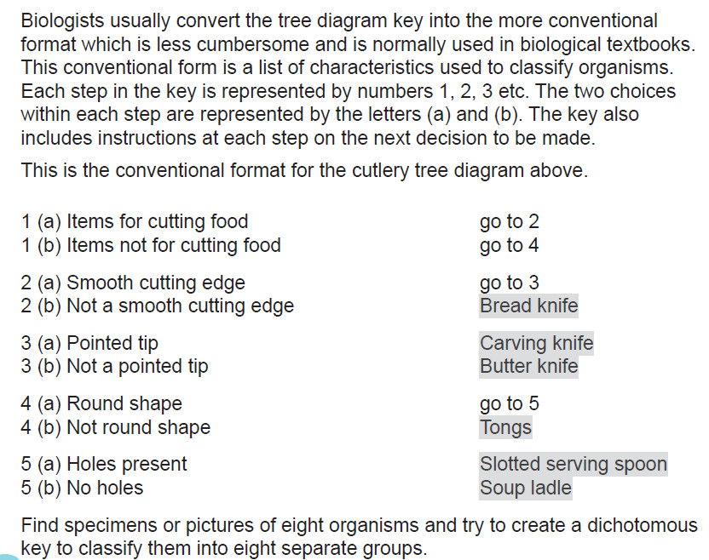

SIDE resources

**Question set 2**

**TASK 1: Classifying garden shed items**

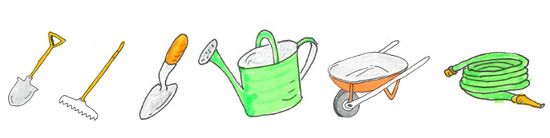

Use the chart below to classify the items found in a garden shed. Cut the pictures on the next page out and stick them onto the chart below. The characteristics have been given for you to use to separate each group. Work through the chart until each item is in a group of its own.



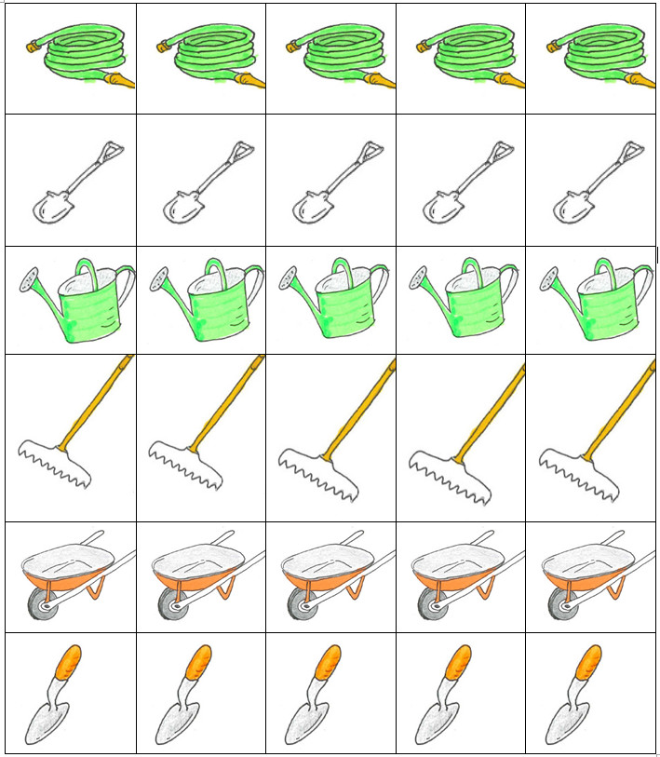

**TASK 2: In the diagram below are a number of organisms, labelled A – L**.

Classify all of the organisms into groups and say on what basis you decided to group the organisms.

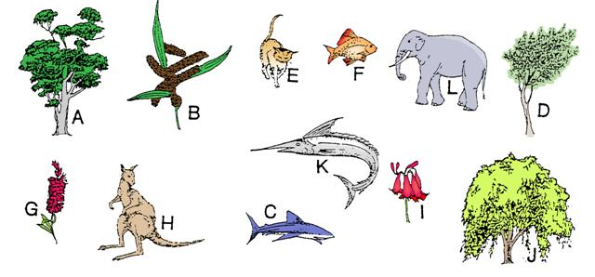

## **Tree diagram**

Specimens (1–12) identified:

| 1 | | 2 | | 3 | | 4 | | 5 | | 6 | |
| --- | --- | --- | --- | --- | --- | --- | --- | --- | --- | --- | --- |
| 7 | | 8 | | 9 | | 10 | | 11 | | 12 | |
|  | | | | | |  | | | | | |
| 1 (a) | | | | |  | | 1 (b) | | | | |
|  | | | | |  | |  | | | | |
|  | | |  | |  | |  | |  | | |
| 2 (a) | | | 2 (b) | |  | |  | |  | | |
|  | | |  | |  | |  | |  | | |
|  | | |  | |  | |  | |  | | |
| 3 (a) | 3 (b) | |  |  |  | |  |  |  | |  |
|  |  | |  |  |  | |  |  |  | |  |

|  |  |  |  |  |  |  |  |  |
| --- | --- | --- | --- | --- | --- | --- | --- | --- |
|  |  |  |  |  |  |  |  |  |

not all boxes need to be used.

Now convert your tree diagram into a dichotomous key.

## **Dichotomous key**

Refer to the example provided previously on Creating a Dichotomous Key for Cutlery and complete a dichotomous key below using your tree diagram of the twelve organisms.

|  |  |  |  |
| --- | --- | --- | --- |
| 1 (a) |  |  | go to 2 |
| 1 (b) |  |  | go to |
|  |  |  |  |
| 2 (a) |  |  |  |
| 2 (b) |  |  |  |
|  |  |  |  |
| 3 (a) |  |  |  |
| 3 (b) |  |  |  |
|  |  |  |  |
| 4 (a) |  |  |  |
| 4 (b) |  |  |  |
|  |  |  |  |
| 5 (a) |  |  |  |
| 5 (b) |  |  |  |
|  |  |  |  |
| 6 (a) |  |  |  |
| 6 (b) |  |  |  |
|  |  |  |  |
| 7 (a) |  |  |  |
| 7 (b) |  |  |  |

**Solutions**

**Question set 1: Grouping things together**

All your life you have been grouping things, Words like tree, dog, car and house are examples of things we have classified. Take houses for example. Not all houses are the same. They usually look different from one another. They have several things in common like a roof, a door and people who live inside them.

Look at the pictures below. They show a variety of vehicles. All images on this page are from

**clipart-library.com**

|  |  |
| --- | --- |
| 2020-04-21_114726 | C:\Users\E0415728\Desktop\Screen captures\2020-04-21_114848.jpg |
| C:\Users\E0415728\Desktop\Screen captures\2020-04-21_114950.jpg | C:\Users\E0415728\Desktop\Screen captures\2020-04-21_115019.jpg |
|  | C:\Users\E0415728\Desktop\Screen captures\2020-04-21_114946.jpg |
| C:\Users\E0415728\Desktop\Screen captures\2020-04-21_114919.jpg | C:\Users\E0415728\Desktop\Screen captures\2020-04-21_114753.jpg |
| C:\Users\E0415728\Desktop\Screen captures\2020-04-21_114825.jpg | C:\Users\E0415728\Desktop\Screen captures\2020-04-21_115055.jpg |
| C:\Users\E0415728\Desktop\Screen captures\2020-04-21_114937.jpg | C:\Users\E0415728\Desktop\Screen captures\2020-04-21_115033.jpg |

List some things they all have in common. Wheels would be one example.

Seat[s], Axles, brakes

\_\_\_\_\_\_\_\_\_\_\_\_\_\_\_\_\_\_\_\_\_\_\_\_\_\_\_\_\_\_\_\_\_\_\_\_\_\_\_\_\_\_\_\_\_\_\_\_\_\_\_\_\_\_\_\_\_\_\_\_\_\_\_\_\_\_\_\_\_\_

Now list some differences between the vehicles.

Number of wheels, number of seats, method of steering, method of locomotion/propulsion

\_\_\_\_\_\_\_\_\_\_\_\_\_\_\_\_\_\_\_\_\_\_\_\_\_\_\_\_\_\_\_\_\_\_\_\_\_\_\_\_\_\_\_\_\_\_\_\_\_\_\_\_\_\_\_\_\_\_\_\_\_\_\_\_\_\_\_\_\_\_

You could group the vehicles into those with headlights and those without headlights or according to colour.

When you sort things into groups we call it **classifying**.

Every day you sort things into groups. You may not even know you are doing it. Take the morning newspaper for example. Usually you have the general news in the first section and the television guide is in the middle. Items for sale and the sports news are found at the back of the paper. Have a look at your local paper to see how it is organised.

**Let’s look at your fridge**.



**Image by clipart-library.com**

In your fridge food has been organised and packed in different groups.

What are some of the groups and why is this useful?

Fruit, meat, dairy products, drinks.

Easier to find food items, check if you are ‘running low ‘on items and if they need to be restocked

\_\_\_\_\_\_\_\_\_\_\_\_\_\_\_\_\_\_\_\_\_\_\_\_\_\_\_\_\_\_\_\_\_\_\_\_\_\_\_\_\_\_\_\_\_\_\_\_\_\_\_\_\_\_\_\_\_\_\_\_\_\_\_\_\_\_\_\_\_\_\_\_\_\_

In your fridge, items are stored in a certain way. Name four things you might classify as vegetables.

Carrots Parsnips

\_\_\_\_\_\_\_\_\_\_\_\_\_\_\_\_\_\_\_\_\_\_\_\_\_\_\_\_\_ \_\_\_\_\_\_\_\_\_\_\_\_\_\_\_\_\_\_\_\_\_\_\_\_\_\_\_\_\_

Brussel sprouts Sweet potatoes

\_\_\_\_\_\_\_\_\_\_\_\_\_\_\_\_\_\_\_\_\_\_\_\_\_\_\_\_\_ \_\_\_\_\_\_\_\_\_\_\_\_\_\_\_\_\_\_\_\_\_\_\_\_\_\_\_\_\_

Onions, celery, cabbage, cauliflower etc.

Name four things you might classify as dairy products.

Milk\_\_\_\_\_\_\_\_\_\_\_\_\_\_\_\_\_\_\_\_\_\_ Butter \_\_\_\_\_\_\_\_\_\_\_\_\_\_\_\_\_\_\_\_\_\_

Cheese\_\_\_\_\_\_\_\_\_\_\_\_\_\_\_\_\_\_ Cream\_\_\_\_\_\_\_\_\_\_\_\_\_\_\_\_\_\_\_\_

**Question set 2**

**TASK 1: Classifying garden shed items**

Decision 1: 1a Wheels 1b No wheels, etc.

**TASK 2: In the diagram below are a number of organisms, labelled A – L**.

Classify all of the organisms into groups and say on what basis you decided to group the organisms.



Decision 1: 1a Plants 1b Animals, etc.